**MIDDLESEX UNIVERSITY**

# CSD3205 -

# Advanced Web Development with Big Data

Recommendation Website based on Machine Learning and Sentiment Analysis

Introduction:

The proposed website for coursework 2, which is to design and build a recommendation website that is based on machine learning and sentiment analysis, will be a crypto recommendation website. This website will give recommendation to its users to which crypto coins or alt coins to invest in. This website will be user friendly by having a simple layout by not having too much visual data and an easy to use navigation design.

Screen Shots Of Website And Wireframe:

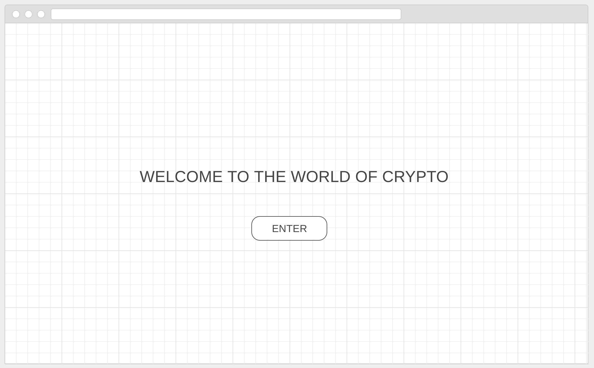

Users will be welcomed to a landing page where there will be a enter button which will direct users to the next page. The text will also have css animation with a rainbow effect going across the x axis.

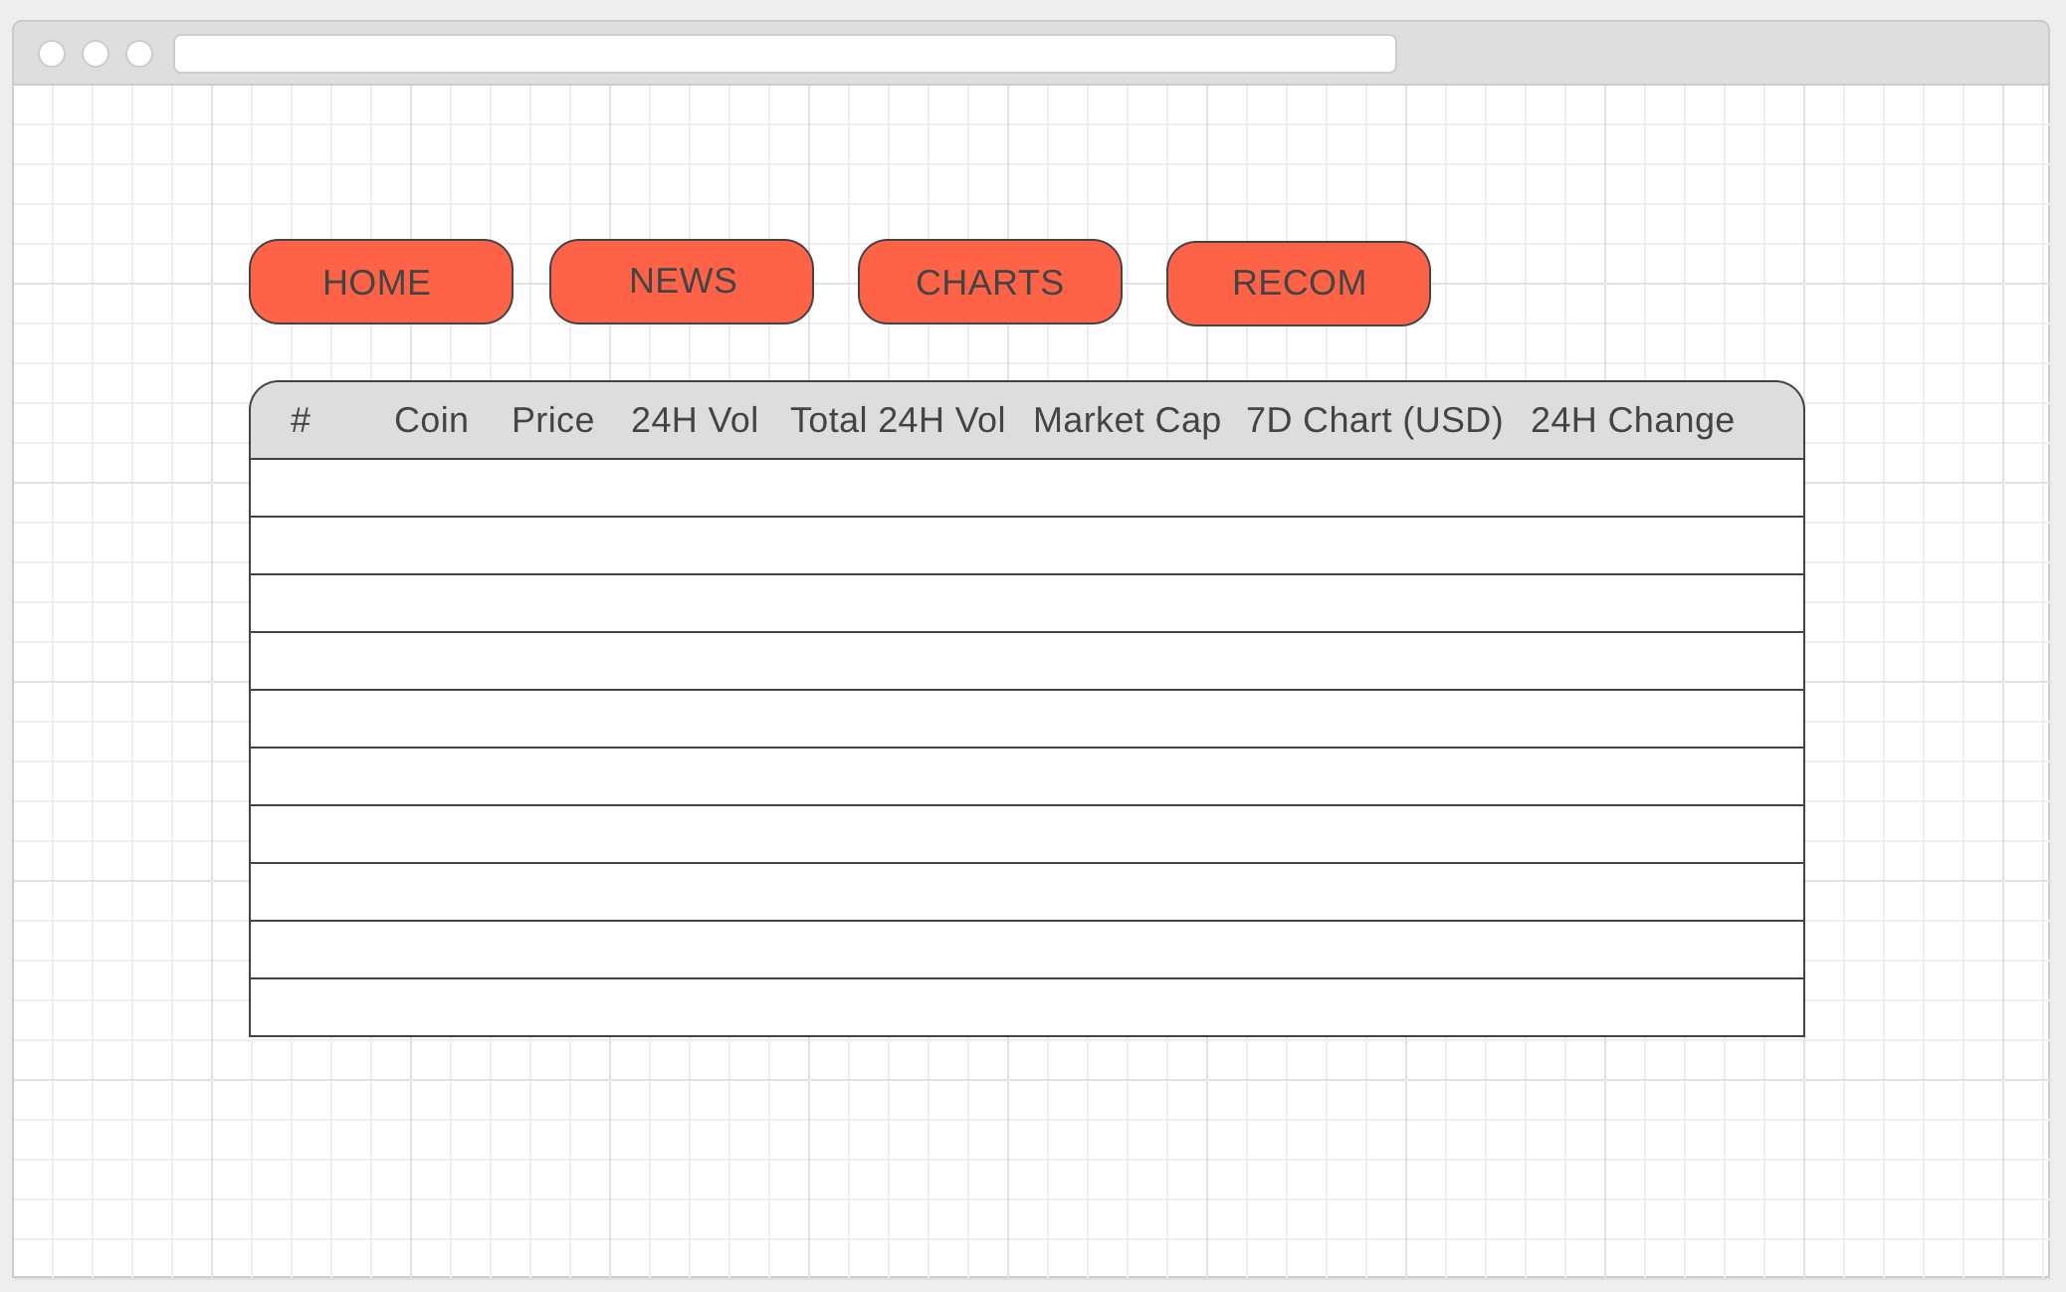

The first page that displays info about the different cryptocurrencies will have the rank, coin name, price, 24h volume, total 24h volume, market cap for the coin, 7d chart in USD, and a 24h change.

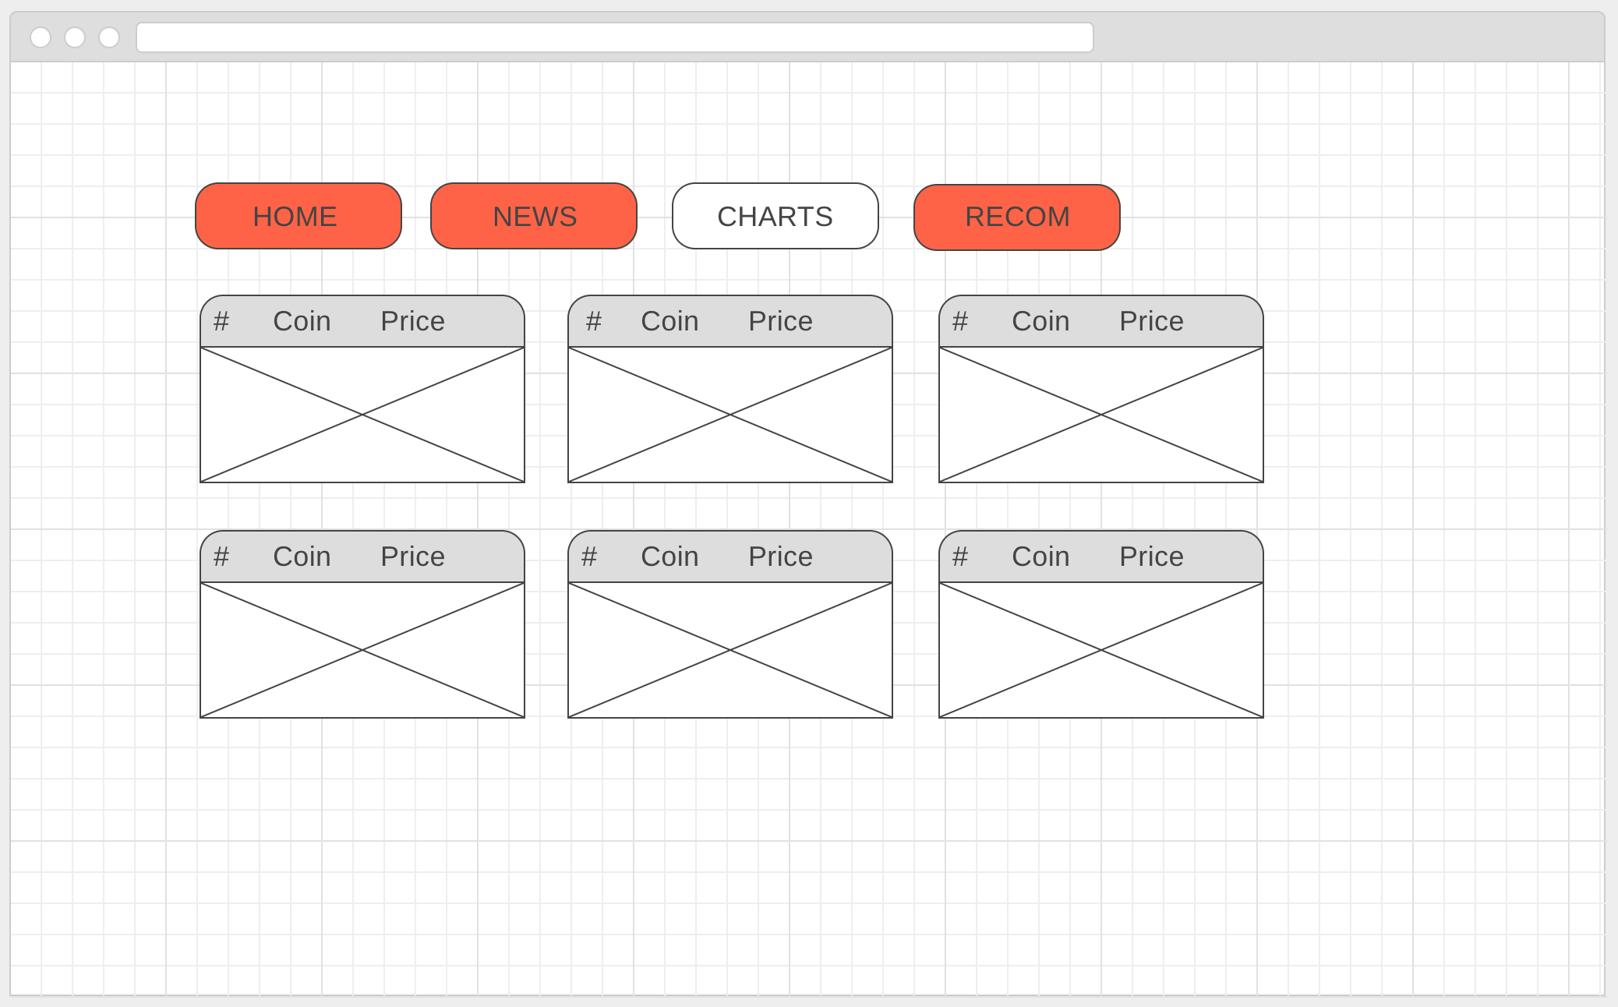

The next page is for charts. This page will display a live graphical chart for all crypt coins.

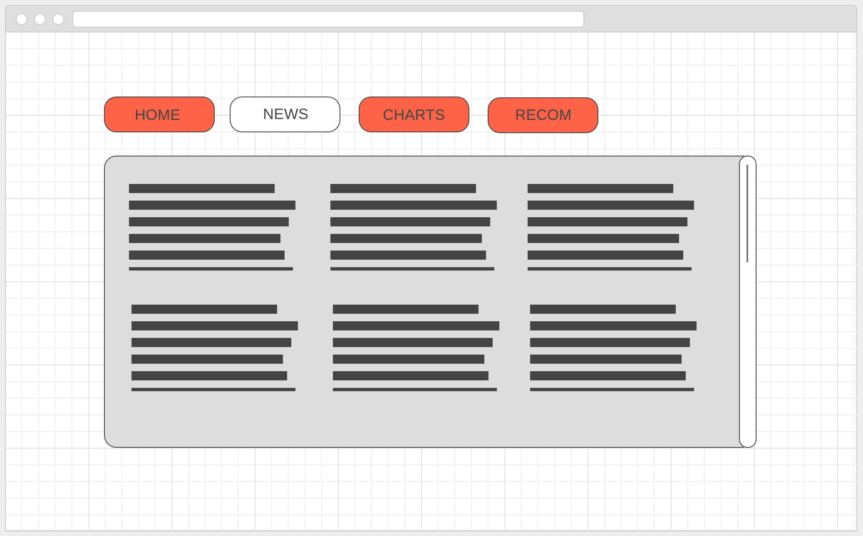

This page will house twitter news feeds specific to cryptocurrency. This will be a live feed using a twitter api.

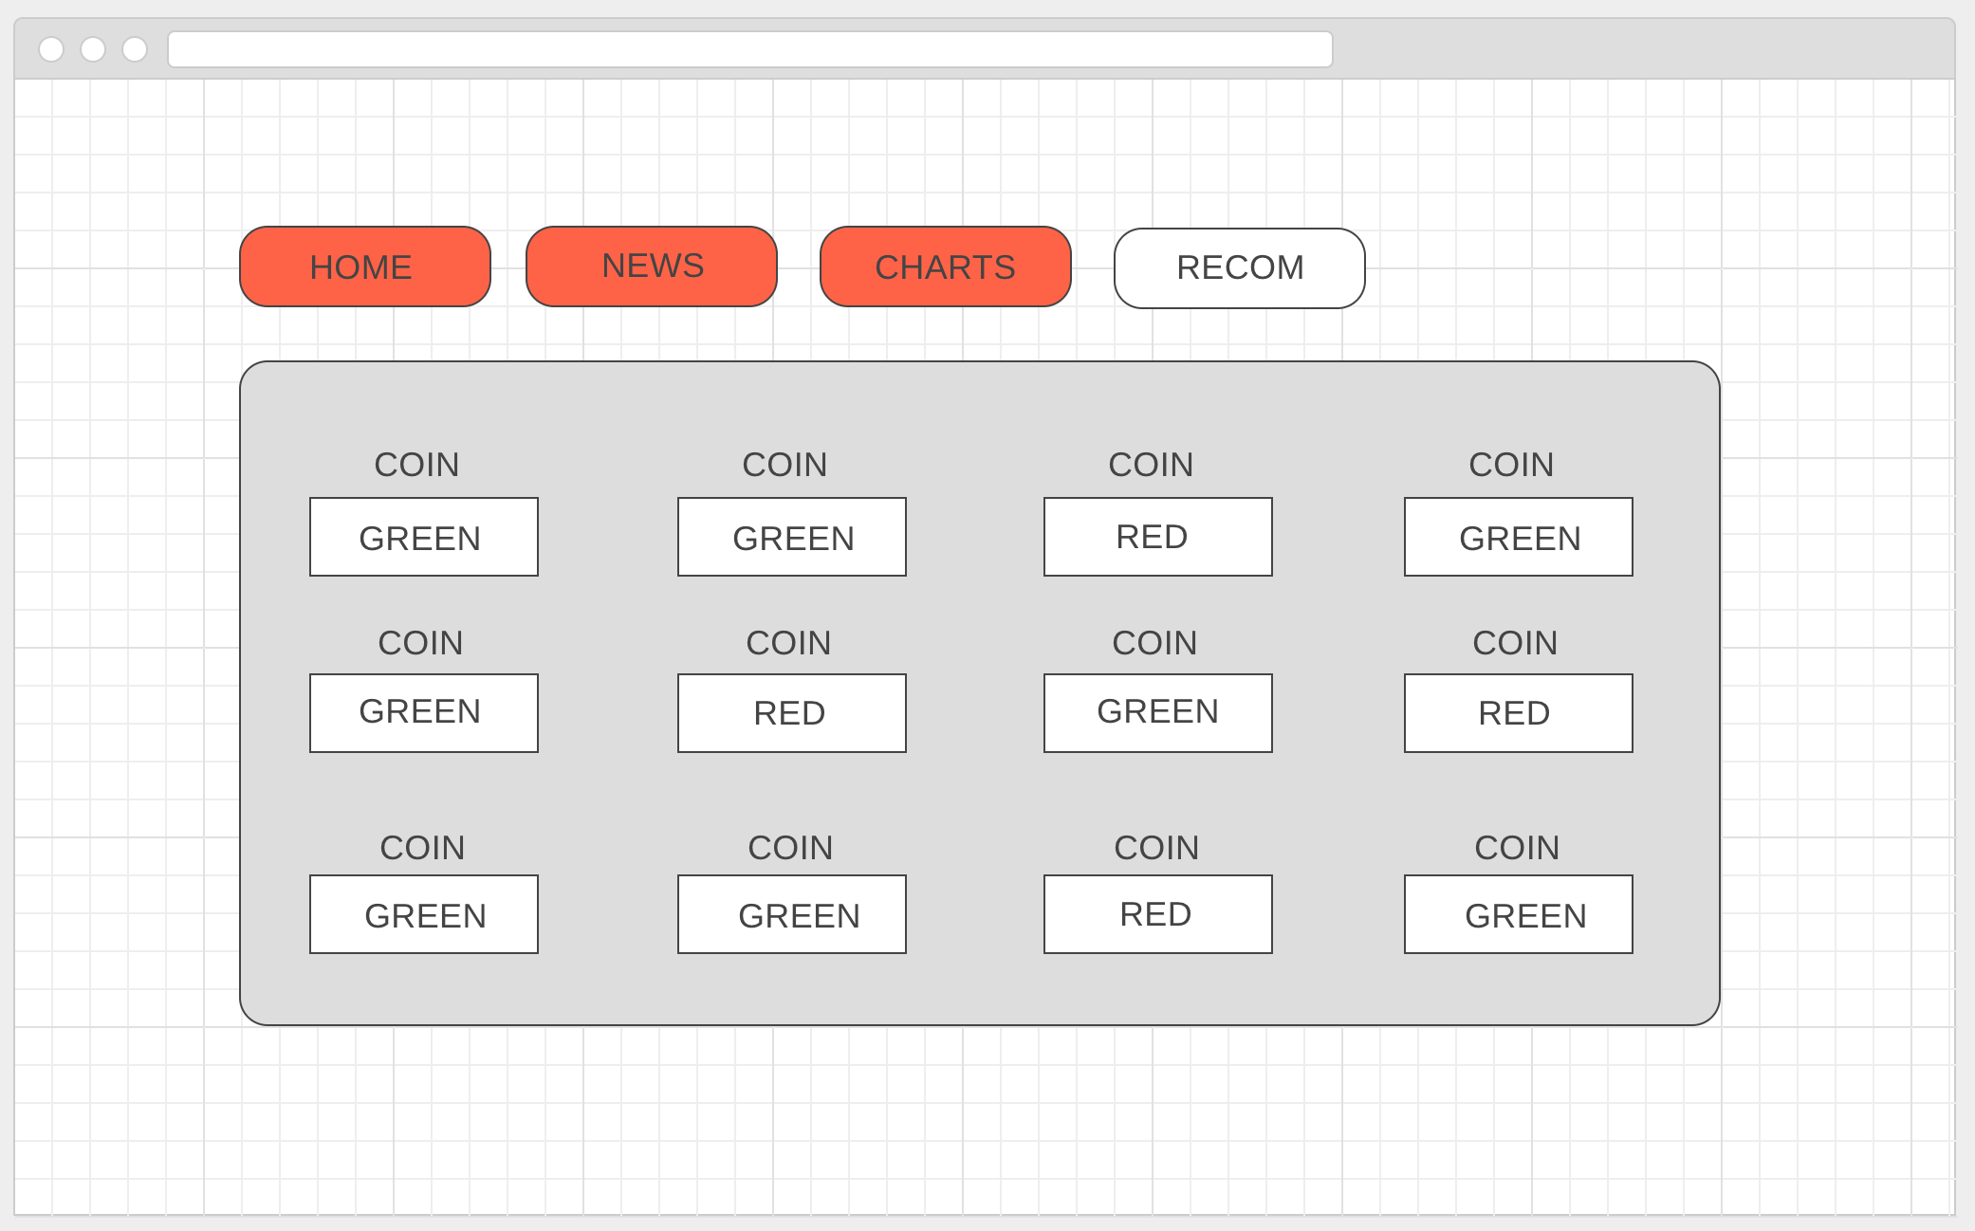

This page will be the recommendation page. It will list all the crypto currencies in a square grid format with a logo bellow each one which will turn green or red.

List of source(s) of numerical data:

<https://coinmarketcap.com/>

<https://coincodex.com/>

<https://www.coinbase.com/>

List of source(s) of data for sentiment analysis:

<https://twitter.com/?lang=en-gb>

<https://en-gb.facebook.com/>

